
University of Central Punjab
Project Report
Nexus Grid Recommendation System
Data STuctures Lab
Data | 10/06/2026
Section | D8

Group Members
No. | Name | Roll Number
1 | Hafiz Muhammad Usman | L1F24BSCS0691
2 | Muhammad Shavaiz Jamil | L1F24BSCS0147
3 | Zulqarnain Saeed | L1F24BSCS0200
4 | Talha Usman | L1F24BSCS0238

1. Introduction
Nexus Grid Recommendation System is a console based C++ project for city emergency and resource support. It connects route finding, emergency priority, inventory record keeping, citizen search, file handling and simple recommendation logic in one menu driven program.
The user loads the project data first, then selects a module from the menu. The system reads the required text files, stores the data in suitable data structures, processes the user request, displays the output on console and writes important actions into log files.
This project is suitable for Data Structures Lab because it shows many structures working together. Graphs manage roads, heaps manage priority, hash tables support fast searching, queues and stacks are used for traversal, trees store sorted data and Huffman coding compresses logs.

Project file view
Item | Details from project folder
Programming language | C++
Main source file | main.cpp
Header files | 23 header files
Text data files | map.txt, inventory.txt, demand_history.txt, citizens.txt, logs.txt, compressedLogs.txt and restoredLogs.txt
Build style | Visual Studio C++ console project

Entry point
The program starts from main.cpp. It creates a SystemIntegrator object and calls startSystem(). This object controls the full application menu and connects all modules.
int main()
{
SystemIntegrator system;
system.startSystem();
return 0;
}

2. Problem Statement
In a city support system, information must be handled quickly. A team may need the shortest route, the most urgent emergency, the available resource stock, or a citizen record. If this data is searched manually, the process becomes slow and mistakes can happen.
The project solves this problem by arranging data in proper structures. Each structure is selected according to the job. For example, routes need a graph, priority cases need heaps and direct searching needs a hash table.

Objectives
- Load city routes, citizens, inventory, demand history and logs from text files.
- Find the fastest route between two locations using a graph and a min heap.
- Process emergency cases according to priority using a max heap.
- Search citizen and inventory records quickly using hash tables.
- Show low stock warnings and restock recommendations using demand history.
- Demonstrate stack, queue, linked list, BST, AVL, heap, graph and Huffman coding.
- Keep system activity in log files and support compression and restoration of logs.

Project scope
Included in project | Not included in project
Console based menu system | Graphical user interface
Text file based storage | Online database server
City route and inventory demo data | Live GPS tracking
Simple prediction and recommendation logic | Large machine learning model
Custom data structure implementation | Ready made database framework

3. Overall Working of the Project
The whole system is controlled by the main menu. After data loading, the user can open navigation, emergency, inventory, search, archive or data structure testing options. Every option sends the work to its own class, so the code remains easier to understand.
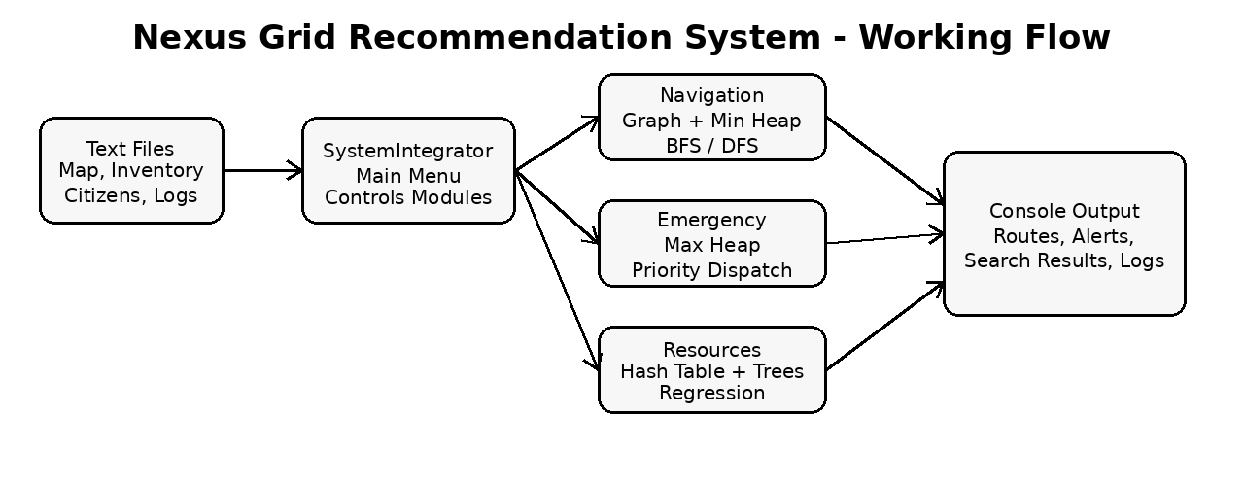

Main menu options
Option | Work done by option
1 | Load map, inventory, demand history and citizen data
2 | Show OOP vehicle demo with ambulance, truck and electric bike
3 - 4 | Add emergency and process the highest priority emergency
5 | Open navigation menu for map display, route, BFS and DFS
6 | Open inventory menu for stock, search, warnings and predictions
7 | Search citizen or inventory records
8 - 10 | Test linked lists, stack, queue, BST, AVL and hash table
11 - 12 | Compress and decompress system logs
13 - 14 | Rotate waiting areas and show regression recommendations

4. Data Structures Used
The main strength of the project is that every important job uses a suitable data structure. This makes the project more practical than using only arrays for all tasks.
Data structure / class | Where it is used | Reason
Graph | City map and road connections | Roads are connected points with distances.
MinHeap | Dijkstra style route calculation | It selects the nearest unvisited location.
MaxHeap | Emergency dispatcher | Highest priority emergency stays on top.
Queue | BFS traversal | BFS needs first-in-first-out order.
Stack | DFS traversal | DFS can use last-in-first-out order.
CircularQueue | Waiting emergency areas | It rotates areas again and again.
HashTable | Citizen and item search | It gives fast search by key.
BST and AVL | Inventory names | They store values in sorted tree form.
DynamicArray | Inventory list | It grows when more items are inserted.
Linked Lists | Lab testing and signal rotation | They show node based memory usage.
Huffman | Log compression | It creates short codes for repeated characters.

5. Navigation and Emergency Modules

Navigation module
The navigation system uses the Graph class. The map file contains one road per line with two locations and a distance. These are saved as vertices and weighted edges. The same graph supports map display, BFS, DFS and shortest path finding.
Data file | Records | Meaning
map.txt | 37 road lines | 29 city locations and 37 connections
Example road | Central_Hospital Rescue_1122 4 | One location is connected with another location by a distance value
For fastest route, the project follows a Dijkstra style method. The min heap helps the program pick the location with the smallest current distance, so route calculation becomes organized and efficient.

Emergency dispatcher module
EmergencyDispatcher handles emergency cases. The user enters location, severity and waiting time. An Emergency object calculates probability, odds, logit, risk score and final priority score. The emergency is then inserted in the MaxHeap.
When the process option is selected, the system extracts the maximum priority emergency. This means the most critical case is dispatched before a lower priority case, even if it was entered later.
Input | Used for
Location | Shows where help is needed
Severity from 1 to 10 | Main danger level
Waiting time in minutes | Increases urgency if the case waits longer
Priority score | Final value used by max heap

6. Inventory, Resource and Recommendation Module
ResourceManager controls stock records. Inventory data is loaded from inventory.txt. Each item has name, quantity, daily use and threshold days. Demand history is loaded from demand_history.txt and is used to estimate future use.
Data file | Records | Purpose
inventory.txt | 35 items | Quantity, daily use and threshold values
demand_history.txt | 35 item histories | Seven day demand values used for prediction
Example item | Oxygen_Cylinder 42 6 4 | Item name with stock and usage values

How stock recommendation works
- The item is loaded into the inventory list and hash table.
- The system calculates days left by dividing quantity by daily use.
- Demand history is checked to see if demand is increasing or decreasing.
- The prediction model estimates next daily use from recent values.
- The system calculates risk values and prints a recommendation message.
- If days left are less than threshold days, the item appears in low stock warnings.
The same inventory information is also added to BST and AVL. This helps the project demonstrate sorted storage and balanced tree concepts. HashTable is used when a single item needs to be found quickly by name.

7. File Handling, Search, Archive and OOP

File handling
FileHandler loads map and citizen data and writes logs. Keeping file reading separate from the menu makes the project easier to manage. The project uses plain text files, so data can be viewed and changed easily during lab testing.
File | Data inside file
citizens.txt | 45 citizen records with ID, name and area
logs.txt | 31 log lines about system actions
compressedLogs.txt | Compressed form of logs after Huffman compression
restoredLogs.txt | Restored log text after decompression

Search module
Citizen search uses citizen ID as the key. The records are loaded as Citizen objects into a hash table. When the user enters an ID, the table searches the key and displays the citizen name and area if the record exists. Inventory search uses the same idea with item names.

Archive module
ArchiveSystem uses Huffman coding. It reads logs.txt, builds character frequency data, creates Huffman codes and writes compressed output. The restore option writes the original log text back into restoredLogs.txt.

OOP vehicle module
The Vehicle class is a base class. Ambulance, Truck and ElectricBike inherit from it. They have their own move and showInfo functions. This demonstrates inheritance, polymorphism and virtual functions in a simple way.

8. Testing and Results
The project can be tested from the main menu. The best method is to load the data first and then test each module one by one. Output is shown on the console, and many operations are also added to logs.txt.
Test case | Expected result
Load data files | Map, inventory, demand history and citizens are loaded
Show map | Road connections are printed location by location
Find fastest route | Shortest path and distance are displayed
BFS / DFS traversal | Locations are visited in traversal order
Search citizen ID | Citizen details are shown if ID exists
Show low stock | Items near restock are listed
Add and process emergency | Highest priority emergency is dispatched first
Compress and decompress logs | Compressed file and restored file are created

Limitations
- The project is console based, so it does not have a graphical screen.
- Data is stored in text files, so it is not designed for many users at the same time.
- The prediction model is simple and suitable for lab demonstration.
- The map is limited to the locations saved in map.txt.

Conclusion
Nexus Grid Recommendation System is a complete Data Structures Lab project because it connects many structures with real tasks. It performs route finding, emergency priority handling, inventory recommendation, fast searching, file handling, log compression and OOP demonstration.
Overall, the project shows that data structures are not only theory. When they are selected correctly, they make a program faster, cleaner and easier to manage.

